**SEATWORK**

**(Midterm)**

**NAME: Mendoza, John Kyle A.**

**COURSE/SECTION: DSP300/IT41FB1**

**Instructions:**

Insert all the screenshots in each of the questions. Create a “Midterm” repo. Update your “Midterm” repo with a commit details of “SW Mditerm - <FULLNAME> <DATE>”. Submit your GITHUB Account Name together with the screenshot of our successful GIT PUSH thru email ([alvinsarragaalon@hotmail.com](mailto:alvinsarragaalon@hotmail.com)) with a subject format of “DSP SW Midterm - <FULLNAME> <DATE>”

**Task 1 using IF**

Extract the subset of rows of the data frame where Ozone values are above 25 and Temp values are above 70. What is the mean of Wind in this subset?

Answers:

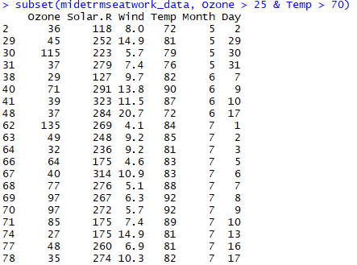 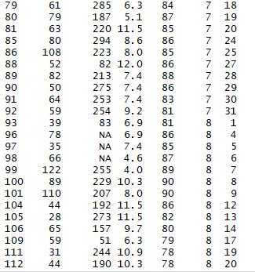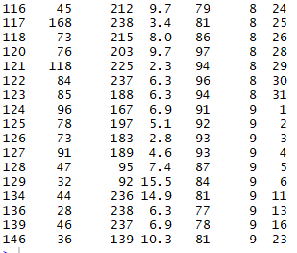

## Task 2 using FOR LOOP

What is the mean of "Temp" when "Month" is equal to 9 and “Day” is equal to 8?

Answers:

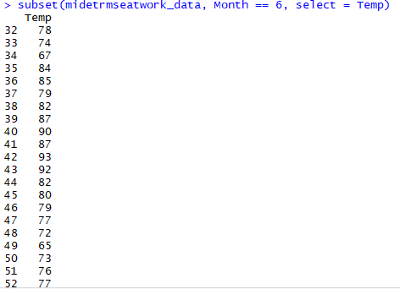

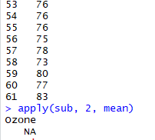 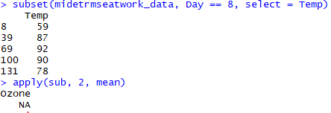

## Task 3 using While

What was the minimum ozone value in each of the month (i.e. Month = 5)??

Answers:

5 = 115, 6 = 71, 7 = 135, 8 = 168, 9 = 91

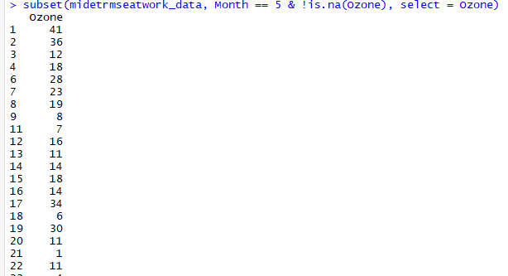

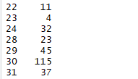

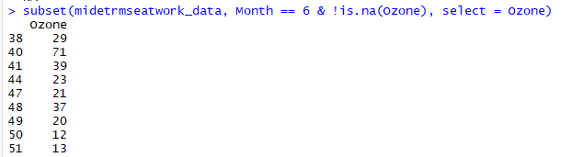

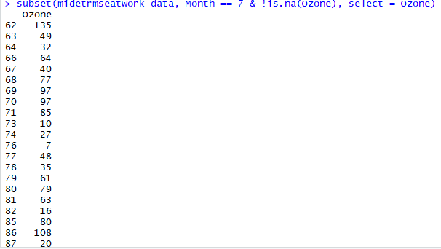

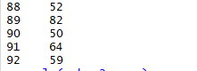

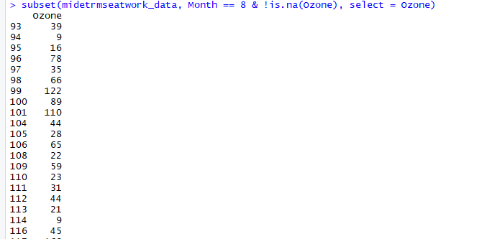

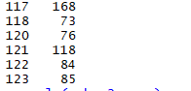

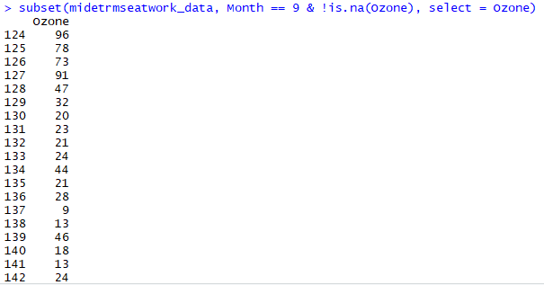

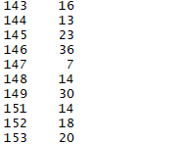

## Task 4 using Repeat, Break, Next

Convert Task 1, Task2, and Task 3 questions using Repeat – Break

Answers: